NAME S SURENDER

REG NO:1924260070

Set 14: Survey Results (Unit IV)

Question 1: Stacked Bar Chart

Aim
To create a stacked bar chart showing the distribution of answers for Question 1 and label its elements.

Procedure
- Load ggplot2 and create the survey data frame.
- Count the answers of each question using table().
- Draw a stacked bar of Question 1 answers with title and axis labels.

Code
library(ggplot2); library(gridExtra)
s <- data.frame(Respondent=1:3, Q1=c("A","B","C"), Q2=c("B","A","A"), Q3=c("C","D","B"))
cnt <- as.data.frame(table(Question=rep(c("Q1","Q2","Q3"), each=3),
Answer=c(s$Q1, s$Q2, s$Q3)))
b <- ggplot(subset(cnt, Question=="Q1"), aes(Question, Freq, fill=Answer))
+
geom_col() + labs(title="Distribution of Answers - Question 1", x="Question", y="Count")
print(b)

Output
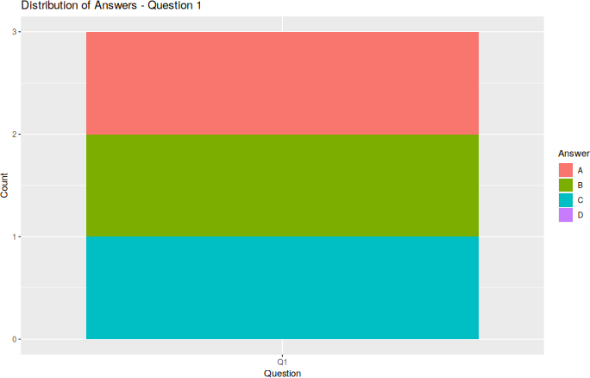
Fig 1: Stacked bar chart – Question 1

Result

The stacked bar chart was created. Answers A, B and C were each chosen once for Question 1 and D was not chosen.

Question 2: Radar Chart

Aim
To visualize the overall pattern of responses across all three questions using a radar chart.

Procedure
- Use the answer counts (cnt) of Questions 1 to 3.
- Draw each answer (A–D) as a polygon on a polar plot with straight edges.
- Add title and legend.

Code
coord_radar <- function() { r <- coord_polar(); r$is_linear <-function(coord) TRUE; r }
r <- ggplot(cnt, aes(Question, Freq, group=Answer, color=Answer)) + geom_polygon(fill=NA) + geom_point() + coord_radar() + ylim(0, 2) + labs(title="Response Pattern (Q1-Q3)")
print(r)

Output
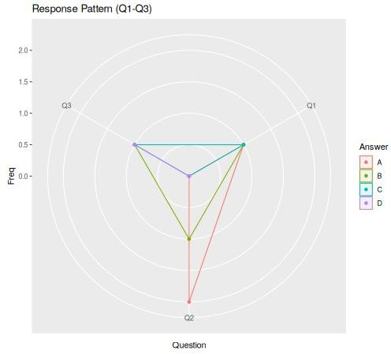
Fig 2: Radar chart – Questions 1 to 3

Result
The radar chart was created. Answer A is strongest on Question 2 (2 responses); B is chosen once on every question.

Question 3: Table

Aim
To build a labelled table showing the survey response data for each respondent.

Procedure
- Print the survey data frame.
- Draw it as a table using tableGrob().

Code
print(s)
t <- tableGrob(s, rows=NULL) grid.arrange(t)

Output

Console output:
Respondent Q1 Q2 Q3
- 1 A B C
- 2 B A D
- 3 C A B

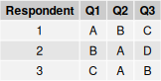

Fig 3: Survey response table

Result
The table of each respondent's answers to Questions 1 to 3 was created with labelled headings.

Question 4: Dashboard

Aim
To combine the stacked bar chart, radar chart and table into one dashboard for exploring the survey responses.

Procedure
  - Use the stacked bar (b), radar chart (r) and table (t) from the earlier questions.
  - Arrange all three in one panel using grid.arrange().

Code
grid.arrange(b, r, t, ncol=2)

Output
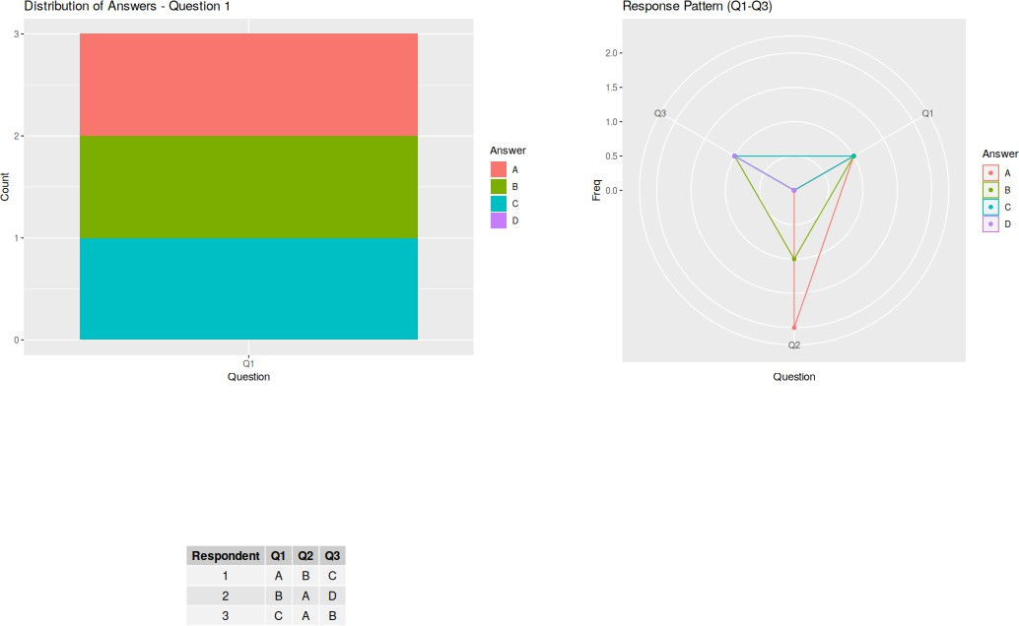

Fig 4: Dashboard (stacked bar + radar + table)

Result
The dashboard combining the stacked bar chart, radar chart and table was created in R.

